**DAILY ONLINE ACTIVITIES SUMMARY**

|  |  |  |  |  |  |  |  |  |
| --- | --- | --- | --- | --- | --- | --- | --- | --- |
| **Date:** | **15/06/2020** | | | | | **Name:** | **RITIKA KULKARNI** | |
| **Sem& Sec** | **4thSEM. & ‘B’ SEC.** | | | | | **USN:** | **4AL19CS403** | |
| **Online Test Summary** | | | | | | | | |
| **Subject** | | **--** | | | | | | |
| **Max. Marks** | | **--** | | **Score** | | | **--** | |
| **Certification Course Summary** | | | | | | | | |
| **Course** | **Introduction of cloud** | | | | | | | |
| **Certificate Provider** | | | **Cognitive class** | | **Duration** | | | **5 Hrs.** |
| **Coding Challenges** | | | | | | | | |
| **Problem Statement:**   1. **Write a C Program to perform the following operations on Triply Linked List (TLL) (i) Insertion at Front of the TLL (ii) Insertion at End of the TLL (iii) Insertion at front of the specified line (iv) Insertion at the end of the specified line (v) Insertion at the specified position in the specified line (vi) Deletion from the Front of the TLL (vii) Deletion from the End of the TLL (viii) Deletion from the front of the specified line (ix) Deletion from the end of the specified line (x) Deletion from the specified position in the specified line. After each operation, you should display the TLL**. 2. **A string is k palindrome if it can be transformed into a palindrome on removing at most k characters from it. Your task is to complete the function is_k_palin which takes two arguments a string str and a number N . Your function should return true if the string is k palindrome else it should return false.** | | | | | | | | |
| **Status: Executed** | | | | | | | | |
| **Uploaded the report in Github** | | | | | **Yes** | | | |
| **If yes Repository name** | | | | | <https://github.com/ritikakulkarni> | | | |
| **Uploaded the report in slack** | | | | | **Yes** | | | |

**Certification Course Summary: Today, I started new Certification course I went through the Introduction of cloud.**

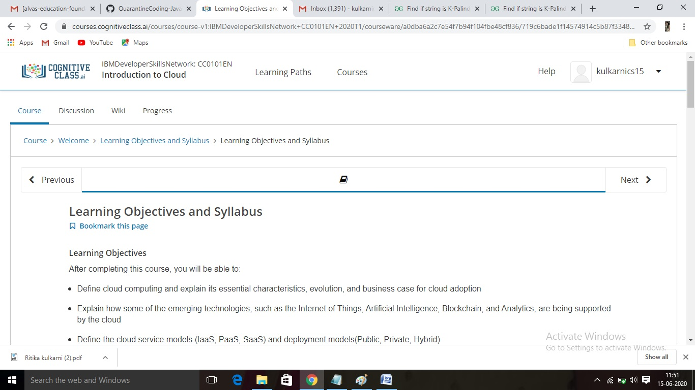

**Online Coding Summary:Online Coding Summary​: Online coding Summary: Today I received two program from Shilpa Mam and Prof. Venkatesh bhat CSE Dept. The program is mentioned above(pg.01). to my GitHub repository and I’ve shared the snapshot below.**

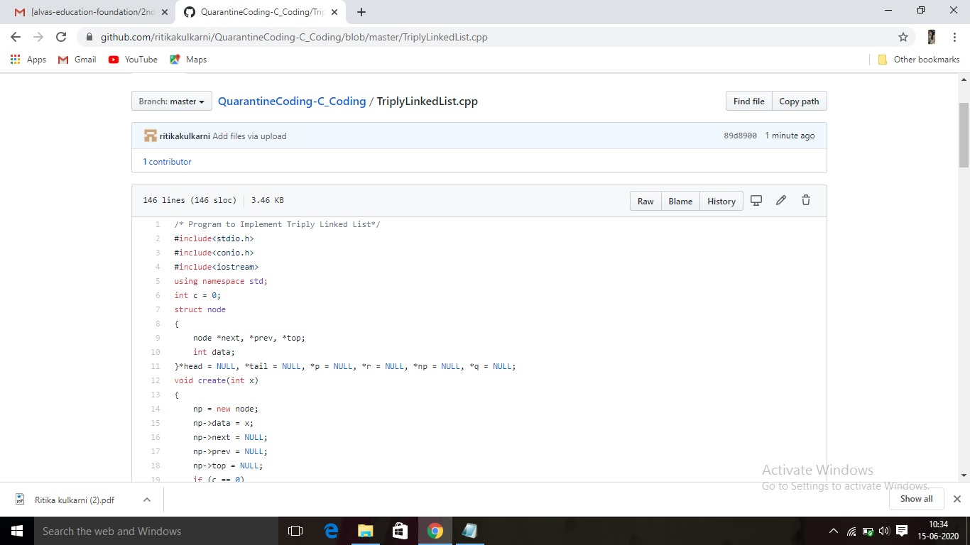

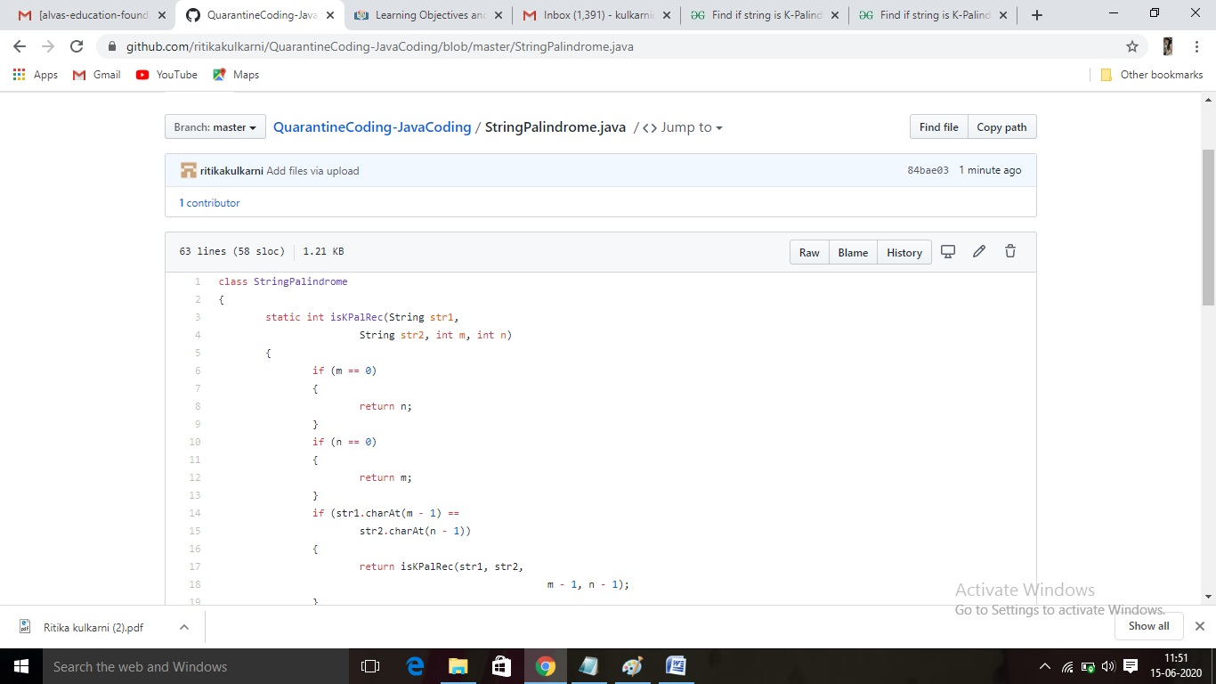 **Thank you.**